**Cloud Functions: Qwik Start - Console**

experimentLabschedule20 minutesuniversal_currency_alt1 Creditshow_chartIntroductory

Rate Lab

**GSP081**



**Overview**

A cloud function is a piece of code that runs in response to an event, such as an HTTP request, a message from a messaging service, or a file upload. Cloud events are *things* that happen in your cloud environment. These might be things like changes to data in a database, files added to a storage system, or a new virtual machine instance being created.

Since cloud functions are event-driven, they only run when something happens. This makes them a good choice for tasks that need to be done quickly or that don't need to be running all the time.

For example, you can use a cloud function to:

* automatically generate thumbnails for images that are uploaded to Cloud Storage.
* send a notification to a user's phone when a new message is received in Cloud Pub/Sub.
* process data from a Cloud Firestore database and generate a report.

You can write your code in any language that supports Node.js, and you can deploy your code to the cloud with a few clicks. Once your cloud function is deployed, it will automatically start running in response to events.

This hands-on lab shows you how to create, deploy, and test a cloud function using the Google Cloud console.

What you'll do

* Create a cloud function
* Deploy and test the function
* View logs

**Setup and requirements**

Before you click the Start Lab button

Read these instructions. Labs are timed and you cannot pause them. The timer, which starts when you click **Start Lab**, shows how long Google Cloud resources will be made available to you.

This hands-on lab lets you do the lab activities yourself in a real cloud environment, not in a simulation or demo environment. It does so by giving you new, temporary credentials that you use to sign in and access Google Cloud for the duration of the lab.

To complete this lab, you need:

* Access to a standard internet browser (Chrome browser recommended).

**Note:** Use an Incognito or private browser window to run this lab. This prevents any conflicts between your personal account and the Student account, which may cause extra charges incurred to your personal account.

* Time to complete the lab---remember, once you start, you cannot pause a lab.

**Note:** If you already have your own personal Google Cloud account or project, do not use it for this lab to avoid extra charges to your account.

How to start your lab and sign in to the Google Cloud console

1. Click the **Start Lab** button. If you need to pay for the lab, a pop-up opens for you to select your payment method. On the left is the **Lab Details** panel with the following:
   * The **Open Google Cloud console** button
   * Time remaining
   * The temporary credentials that you must use for this lab
   * Other information, if needed, to step through this lab
2. Click **Open Google Cloud console** (or right-click and select **Open Link in Incognito Window** if you are running the Chrome browser).

The lab spins up resources, and then opens another tab that shows the **Sign in** page.

***Tip:*** Arrange the tabs in separate windows, side-by-side.

**Note:**If you see the **Choose an account** dialog, click **Use Another Account**.

1. If necessary, copy the **Username** below and paste it into the **Sign in** dialog.

"Username"

Copied!

content_copy

You can also find the **Username** in the **Lab Details** panel.

1. Click **Next**.
2. Copy the **Password** below and paste it into the **Welcome** dialog.

"Password"

Copied!

content_copy

You can also find the **Password** in the **Lab Details** panel.

1. Click **Next**.

**Important:**You must use the credentials the lab provides you. Do not use your Google Cloud account credentials.**Note:**Using your own Google Cloud account for this lab may incur extra charges.

1. Click through the subsequent pages:
   * Accept the terms and conditions.
   * Do not add recovery options or two-factor authentication (because this is a temporary account).
   * Do not sign up for free trials.

After a few moments, the Google Cloud console opens in this tab.

**Note:** To view a menu with a list of Google Cloud products and services, click the **Navigation menu** at the top-left. 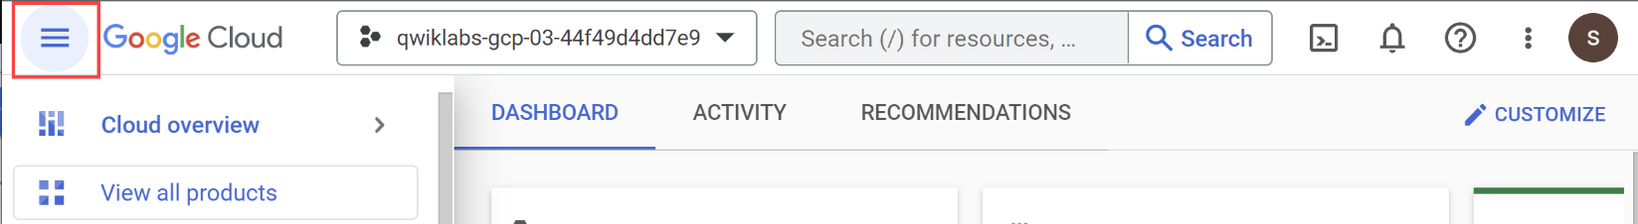

**Task 1. Create a function**

In this step, you're going to create a cloud function using the console.

1. In the console, click the **Navigation menu (Navigation Menu icon)** > **Cloud Functions**.
2. Click **Create function**.
3. In the **Create function** dialog, enter the following values:

|  |  |
| --- | --- |
| **Field** | **Value** |
| Environment | 2nd Gen |
| Function name | GCFunction |
| Region | REGION |
| Trigger type | **HTTPS** |
| Authentication | Allow unauthenticated invocations |
| Memory allocated (In Runtime, Build, Connections and Security Settings) | Keep it default |
| Autoscaling | Set the **Maximum number of instance** to **5** and then click **Next** |

**Note:** A helpful popup may appear to validate the required APIs are enabled in the project. Click the **ENABLE** button when requested.

You deploy the function in the next section.

**Task 2. Deploy the function**

1. Still in the **Create function** dialog, in Source code for **Inline editor** use the default helloWorld function implementation already provided for index.js.
2. At the bottom, click **Deploy** to deploy the function.
3. After you click **Deploy**, the console redirects to the **Cloud Functions Overview** page.

**Note:**While the function is being deployed, the icon next to it is a small spinner. When it's deployed, the spinner is a green check mark.

Test completed task

Click **Check my progress** to verify your performed task. If you have completed the task successfully you will be granted an assessment score.

Deploy the function.

Check my progress

**Task 3. Test the function**

Test the deployed function.

1. In the **Cloud Functions Overview** page, click on **GCFunction**.

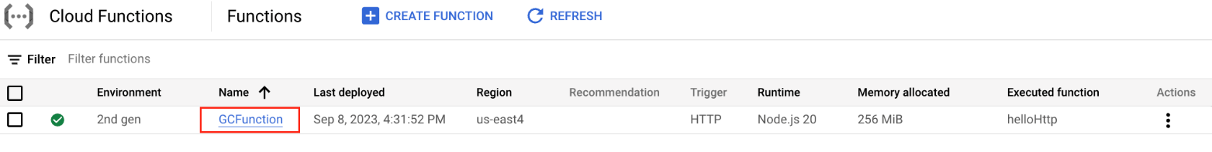

1. On function details dashboard, to test the function click on **TESTING**.

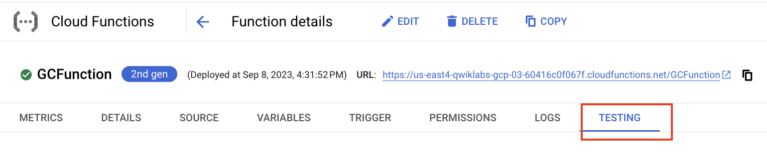

1. In the Triggering event field, enter the following text between the brackets {} and click **Test the function**.

"message":"Hello World!"

Copied!

content_copy

In the **Output** field, you should see the message Success: Hello World!

In the **Logs** field, a status code of **200** indicates success. (It may take a minute for the logs to appear.)

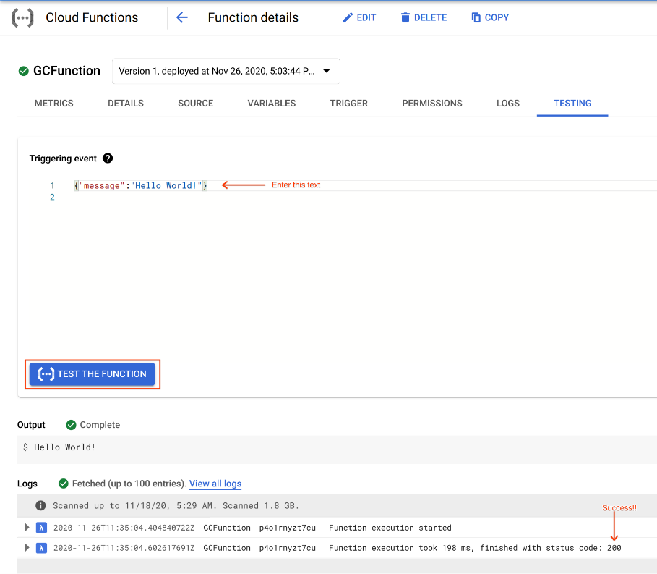

**Task 4. View logs**

View logs from the Cloud Functions Overview page.

1. Click the blue arrow to go back to the **Cloud Functions Overview** page.

Blue arrow

1. Display the menu for your function, and click **View logs**.

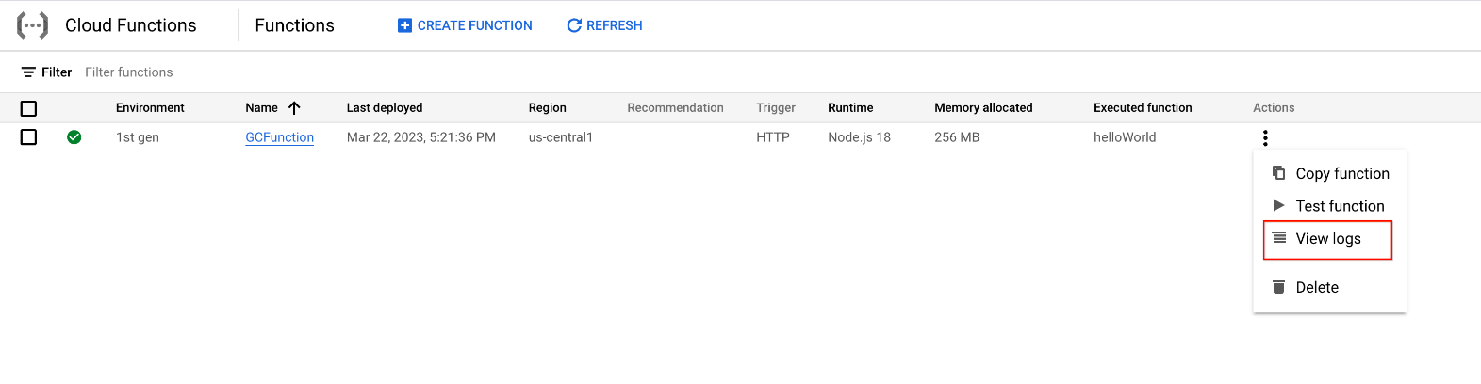

Example of the log history that displays in **Query results**:

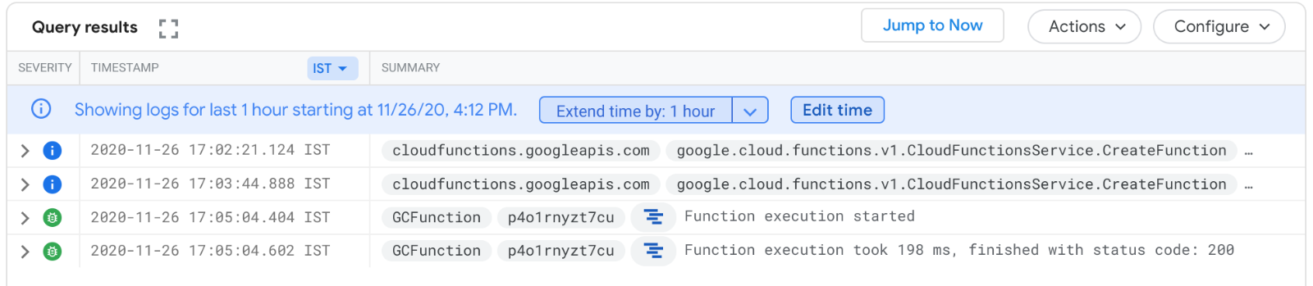

Your application is deployed, tested, and you can view the logs.

Test the function

Check my progress

**Task 5. Test your understanding**

Below are multiple-choice questions to reinforce your understanding of this lab's concepts. Answer them to the best of your abilities.

Cloud Functions is a serverless execution environment for event driven services on Google Cloud.



True



False

Which type of trigger is used while creating Cloud Function in the lab?



Cloud Storage



Firebase



Google Cloud Pub/Sub



HTTP

Submit

**Congratulations!**

You used the Google Cloud console to create, deploy, and test a cloud function.

Take your next lab

* This lab is also part of a series of labs called Qwik Starts. These labs are designed to give you a little taste of the many features available with Google Cloud. Search for "Qwik Starts" in [Google Cloud Skill Bost](https://google.qwiklabs.com/catalog) to find the next lab you'd like to take!
* Now that you used the console to start a Google Cloud Function, try and compare starting a Cloud Function using the command line. See [Cloud Functions: Qwik Start - Using the Command Line](https://google.qwiklabs.com/catalog_lab/924).

Next steps / Learn more

* For more information on creating triggers and associating them with your functions, see [the Events and Triggers section of the Cloud Functions Guides](https://cloud.google.com/functions/docs/concepts/events-triggers).

Google Cloud training and certification

...helps you make the most of Google Cloud technologies. [Our classes](https://cloud.google.com/training/courses) include technical skills and best practices to help you get up to speed quickly and continue your learning journey. We offer fundamental to advanced level training, with on-demand, live, and virtual options to suit your busy schedule. [Certifications](https://cloud.google.com/certification/) help you validate and prove your skill and expertise in Google Cloud technologies.

**Manual Last Updated January 26, 2024**

**Lab Last Tested September 19, 2023**

Copyright 2024 Google LLC All rights reserved. Google and the Google logo are trademarks of Google LLC. All other company and product names may be trademarks of the respective companies with which they are associated.

[navigate_beforePrevious](https://www.cloudskillsboost.google/course_sessions/14297640/labs/464353)[Nextnavigate_next](https://www.cloudskillsboost.google/course_sessions/14297640/labs/464355)